PROJECT BASED LEARNING

PROTOTYPE / DESIGN BUILDING

REPORT

ON

CITY FOOD EXPLORER

A Report submitted

by

B.AKHILA, 21951A0410

N.AMULYA, 21951A0416

K.SRISHA, 21951A0419

M.ANUSHA, 21951A0421



Electronics and Communication Engineering
INSTITUTE OF AERONAUTICAL ENGINEERING

(Autonomous)

Dundigal, Hyderabad–500 043, Telangana

March, 2024

- Define the problem statement and its relevance to today's market / society / industry need.

The problem statement for the City Food Explorer is the lack of a comprehensive and user-friendly platform that facilitates exploration and discovery of diverse food options within a city. In today's market, where consumers crave unique culinary experiences, existing food apps often fall short in providing a consolidated guide to the varied food landscape. The City Food Explorer aims to bridge this gap by offering a centralized platform that caters to the growing demand for personalized and diverse dining experiences.

In the context of society, where food culture plays a significant role, this problem resonates with individuals seeking authenticity and variety in their culinary adventures. The app addresses the societal need for a tool that goes beyond generic recommendations, fostering a deeper connection with local food scenes and promoting cultural exploration through gastronomy.

In the industry, there is a rising trend towards niche and specialized services, and the City Food Explorer aligns with this by catering specifically to the food exploration niche. It meets the industry's demand for innovative solutions that enhance user experience and engagement in the realm of dining and hospitality. Overall, the problem statement underscores the app's relevance in today's market, society, and industry by addressing the evolving preferences and expectations related to food discovery and exploration.

- City Food Guides:

City food guides typically offer details about restaurants, cafes, street food vendors, and other culinary experiences in a specific city or region. These guides may include reviews, ratings, menus, and recommendations to help users explore and discover the local food scene. ✓ If "City Food Guide" is a specific service or entity, I recommend checking online sources, app stores, or official websites for the most up-to-date and accurate information. You can also look for user reviews or articles that may provide insights into the features and offerings of the City Food Guide you are referring to.

- Education:

The "Education" page enriches your project by offering culinary learning resources, nutrition guides, cooking classes, and insights from renowned chefs. It serves as a valuable hub for users seeking to enhance their culinary skills, make informed nutritional choices, and explore the science and artistry behind food.

- Dining guide:

City food and dining guides seamlessly blend culinary exploration with education. These guides offer insights into local history, cooking classes, and ingredient details, enriching users' understanding of diverse cuisines. Guided food tours, online resources, and collaborations with educational institutions further enhance the immersive experience, providing a comprehensive and educational approach to discovering the vibrant culinary landscape of a city.

- Food handling guide:

City food and Food handling guides seamlessly blend culinary exploration with education. These guides offer insights into local history, cooking classes, ingredient details, and food handling guides, enriching users' understanding of diverse cuisines. Guided food tours, online resources, and collaborations with educational institutions provide a comprehensive and educational approach to discovering a city's vibrant culinary landscape.

- Restaurants:

The “Restaurant” page in your project serves as a comprehensive guide, providing users with details on diverse dining options, including restaurant reviews, cuisines, and ambiance. It facilitates informed decision-making for users seeking delightful culinary experiences in the city’s vibrant food scene.

- Reports:

The report page in your project serves as a comprehensive overview, presenting key findings, analyses, and insights. It consolidates data, communicates project progress, and facilitates informed decision-making. This centralized documentation ensures stakeholders can easily access and understand crucial information, enhancing project transparency and accountability.

- Feedback:

The feedback page in your project serves as a valuable tool for gathering user opinions and suggestions. It fosters communication, allowing users to share their experiences, report issues, and propose improvements. This input is crucial for refining and enhancing the project, ensuring it aligns with user expectations and needs.

- Describe the proposed Solution and Methodology / Developed towards the product/process (Max: 250 Words)

The City Food Explorer proposes a cutting-edge mobile application designed to revolutionize urban gastronomic adventures. The methodology involves a meticulous approach to user satisfaction and engagement through various features. The user interface is crafted for simplicity and elegance, ensuring accessibility for all users. A comprehensive database spans diverse cuisines and local eateries, employing a powerful search algorithm for effortless discovery.

Personalization takes center stage, utilizing machine learning to tailor recommendations based on individual preferences and behaviors. Real-time updates keep users informed about new establishments, events, and exclusive offers. User engagement is fostered through interactive features, allowing reviews and ratings to contribute to a vibrant community.

Location-based services enhance user experience, providing accurate suggestions based on the user's current locale, coupled with integrated maps for seamless navigation. Strategic collaborations with local businesses ensure up-to-date information and exclusive deals for City Food Explorer users.

Continuous improvement is a core tenet, with regular updates integrating user feedback and tracking emerging food trends. This holistic methodology positions City Food Explorer as the go-to platform for those seeking not just meals but curated, personalized culinary experiences, thereby addressing the demands of today's dynamic market and society's inclination towards diverse and authentic dining adventures.

- Explain the uniqueness and distinctive features of the product / process / service solution (Max: 200 Words)

The City Food Explorer distinguishes itself with a set of unique features that redefine the landscape of culinary exploration applications. At its core, the app employs advanced machine learning algorithms to understand and adapt to individual user preferences, offering a personalized journey through the diverse world of local eateries.

What truly sets City Food Explorer apart is its comprehensive database, a treasure trove encompassing a myriad of cuisines and specialties. From hidden gems to well-known establishments, users can explore a rich tapestry of culinary delights, ensuring a satisfying and varied experience. Real-time updates inject dynamism into the user experience, delivering instant notifications about new restaurant openings, special events, and exclusive deals. This real-time engagement keeps users connected to the pulse of their local food scene.

User-generated content forms a vibrant community within the app, allowing individuals to contribute reviews and ratings. This not only fosters trust but also adds a communal dimension, turning the app into a shared platform for culinary enthusiasts. The integration of location-based services and navigation ensures that users receive accurate and relevant suggestions based on their current locale, adding a layer of convenience to their gastronomic exploration.

Strategic collaborations with local businesses further enhance the app's reliability and value, providing users with up-to-date information and exclusive promotions. Continuous innovation, with regular updates and a keen eye on emerging food trends, cements City Food Explorer as a dynamic and indispensable tool for those seeking curated, authentic, and ever-evolving culinary adventures.

- Utility: Highlight the utility/value proposition (key benefits) aspects of the solution/innovation* (Max: 150 Words)

The City Food Explorer revolutionizes local dining experiences by offering a utility-rich platform with a host of key benefits. Its personalized culinary journeys cater to individual tastes, ensuring that each user's exploration is uniquely satisfying.

Real-time engagement is a cornerstone of its utility, delivering instant updates on new restaurant openings, special events, and exclusive deals, fostering a sense of connection to the dynamic local food scene. The community-driven experience, encouraged through user-generated content like reviews and ratings, transforms the app into a shared platform where culinary enthusiasts connect and exchange experiences.

Seamless exploration is facilitated by location-based services, allowing users to discover relevant suggestions based on their current location, simplifying the journey to culinary delights. Exclusive collaborations and promotions with local businesses further enhance the app's value, providing users not only with accurate and up-to-date information but also access to special deals. With continuous innovation and trend tracking, the City Food Explorer ensures users stay ahead in their culinary adventures, solidifying its utility proposition as a dynamic, personalized, and indispensable tool for those seeking curated, authentic, and ever-evolving local food experiences.

- Scalability: Highlight the market potential aspects of the Solution/Innovation (Potential Market Size, segmentation and Target users/customers etc.)

The City Food Explorer exhibits significant scalability with a vast market potential. The app's appeal spans diverse urban demographics, attracting food enthusiasts, tourists, and locals seeking authentic culinary experiences. The potential market size is expansive, encompassing metropolitan areas globally where diverse food scenes thrive. Market segmentation caters to various user preferences, including those interested in specific cuisines, trending eateries, or unique dining experiences.

Target users range from tech-savvy millennials looking for the latest food trends to families seeking family-friendly dining options. Additionally, tourists exploring new cities constitute a substantial target audience. The app's scalability is evident in its adaptability to different cultures and culinary landscapes, making it applicable across various cities worldwide. With the increasing global interest in diverse and personalized dining experiences, the City Food Explorer is poised for scalable growth, tapping into a broad and ever-expanding market.

- Environmental Sustainability: Highlight environmental friendliness aspects and related benefit of the solution/innovation

The City Food Explorer champions environmental sustainability by promoting conscious dining choices and reducing the carbon footprint associated with the food industry. By encouraging users to explore local and sustainable eateries, the app supports environmentally friendly practices. Its emphasis on diverse cuisines helps showcase the richness of plant-based and eco-friendly dining options, contributing to a more sustainable food ecosystem.

Moreover, the City Food Explorer actively engages with environmentally responsible businesses, fostering a network that prioritizes sustainable practices. The app's real-time updates can highlight eateries with eco-friendly initiatives, such as reducing single-use plastics or sourcing locally, further incentivizing users to make environmentally conscious dining decisions. In this way, the City Food Explorer becomes a catalyst for positive change, aligning gastronomic exploration with environmental sustainability and influencing users to make eco-friendly choices in their dining experiences.

- Utility: Highlight the utility/value proposition (key benefits) aspects of the solution/innovation* (Max: 100 Words)

CITY FOOD EXPLORER brings unparalleled utility by seamlessly integrating artificial intelligence with the joy of urban dining. The app's key benefits lie in its personalized recommendations, using advanced algorithms to understand and cater to individual tastes. It simplifies the exploration of local culinary scenes through intuitive geolocation features, ensuring users discover diverse and unique dining experiences effortlessly.

The community engagement aspect adds value by allowing users to share reviews and recommendations, creating a dynamic food-loving network. Real-time promotions enhance affordability, making dining out more accessible. Moreover, CITY FOOD EXPLORER champions local businesses, contributing to the vibrancy of neighborhoods. With a sleek interface and commitment to enhancing the overall dining experience, this innovative solution transforms city exploration into a delightful journey, offering not just convenience but a community driven and personalized approach to urban gastronomy.

- Details of Prototype

Components | List out all the components / software’s/ tools used  - JAVA SCRIPT ( Frontend, Backend )  - HTML  - CSS  - Software Using VS CODE
Images of prototype | 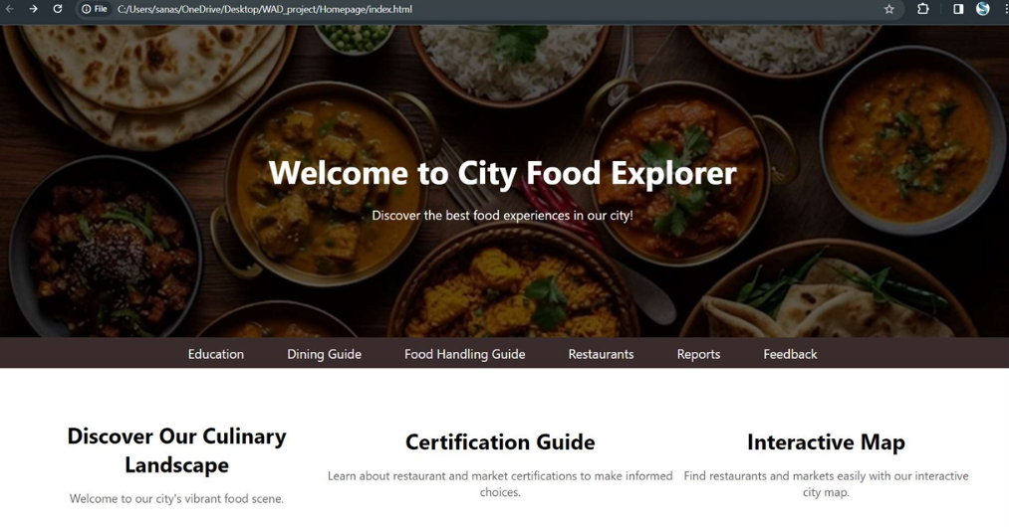  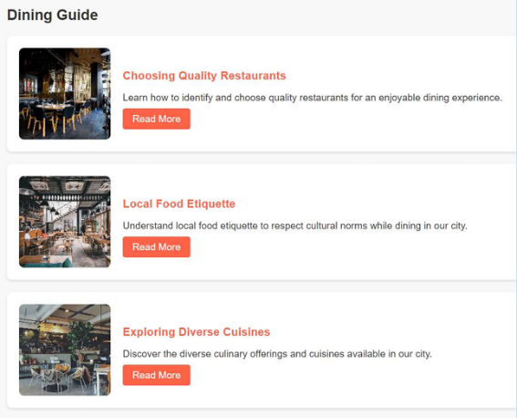  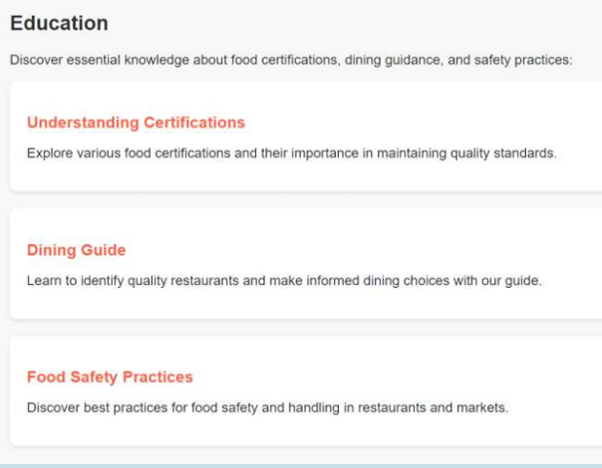

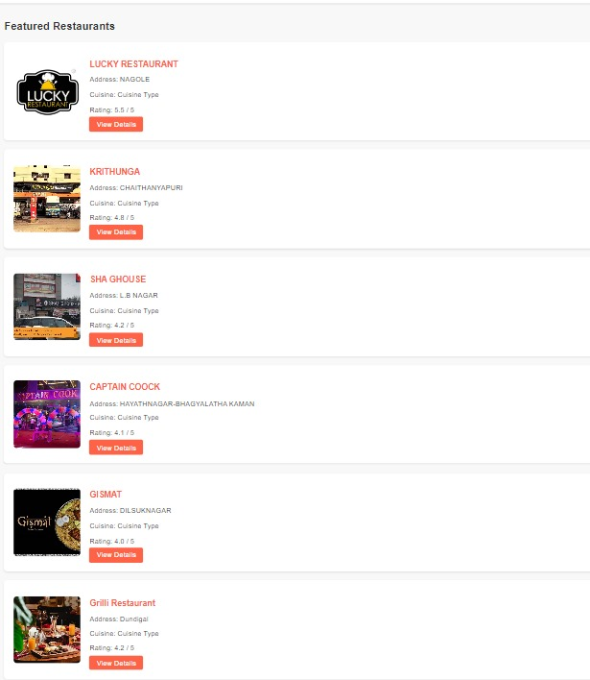
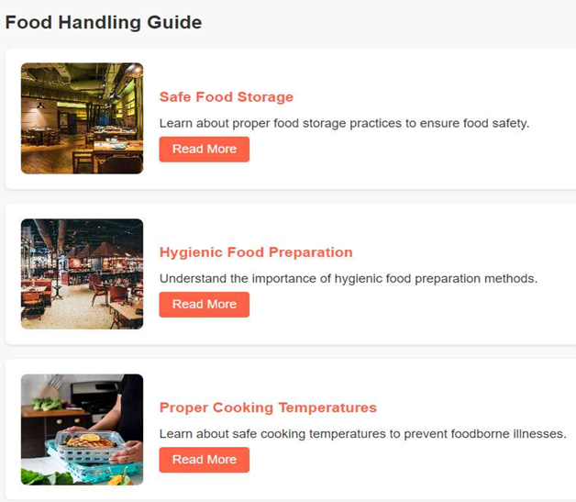

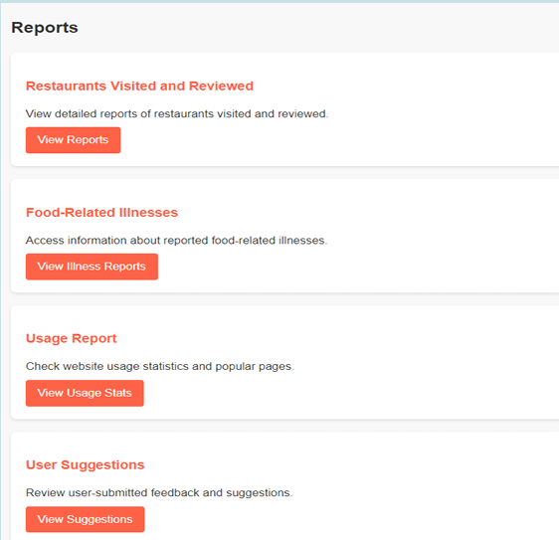

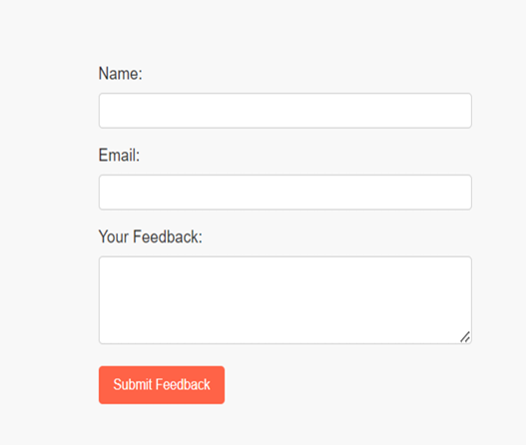

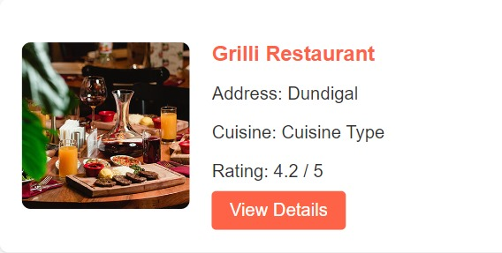

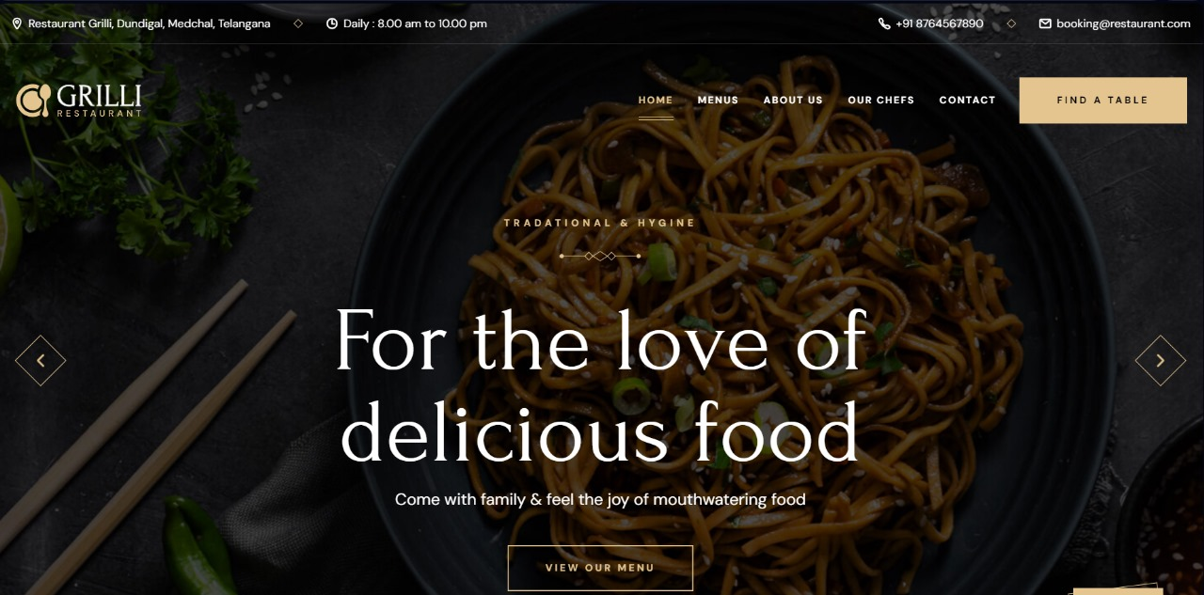

- Scalability: Highlight the market potential aspects of the Solution/Innovation (Potential Market Size, segmentation and Target users/customers etc.) (Max: 100 Words)

CITY FOOD EXPLORER demonstrates immense scalability with its broad market potential. Targeting urban populations globally, the potential market size is extensive, as the platform aligns with the growing worldwide trend of culinary exploration and digital innovation in the food industry. Segmentation is strategically designed to appeal to various demographics, including tech-savvy millennials seeking diverse dining experiences, working professionals navigating urban life, and individuals with specific dietary preferences or restrictions. The platform's adaptability allows it to seamlessly integrate into different city landscapes, appealing to the unique tastes and preferences of each locale. Its scalability is further accentuated by the inclusion of local businesses—restaurants, cafes, and food markets—looking to enhance their visibility and connect with a digitally engaged customer base. As CITY FOOD EXPLORER emphasizes community engagement, it appeals to users seeking not only convenience in their dining choices but also a sense of connection and shared experiences.

- REFERENCE:

Video URL:

https://drive.google.com/file/d/1H3ESQ7b_quuElXqdRrXRpiWD Y4vCbyHx/view?usp=drive_link

Signature of the faculty

